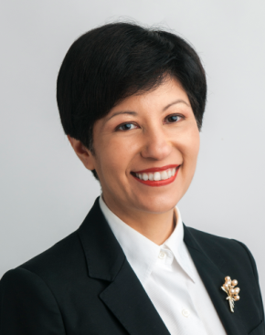

Indranee THURAI RAJAH
Minister in the Prime Minister’s Office
Second Minister for Finance and Education
Member of Parliament
for Tanjong Pagar GRC

Ms Indranee Rajah is the Minister in the Prime Minister’s Office. She is also Second Minister for Finance and Education.

She was educated at Raffles Institution in Singapore, and read law at the National University of Singapore. She was admitted to the Singapore Bar in 1987 and had an active practice in Civil and Commercial Litigation and international arbitration. She was appointed Senior Counsel in 2003. She was Deputy Head of Drew & Napier’s Dispute Resolution Department until October 2012, when she left to join the government.

Ms Rajah has been the Member of Parliament for the Tanjong Pagar Group Representation Constituency (GRC) since 2001. She chaired the Government Parliamentary Committee (GPC) for Law & Home Affairs from 2004 to 2006 and the GPC for Defence and Foreign Affairs from 2006 to mid-2009. She was a Deputy Speaker of Parliament from 2006 to 2011.

She was appointed Senior Minister of State for Law and Education in 2012. Under her law portfolio she co-chaired the Committees on Family Justice, the formation of the Singapore International Commercial Court as well as the committee on Strengthening Singapore as a Restructuring Hub. She also helmed the Steering Committee on the strategic direction of Singapore’s third law school at UniSIM.

In her education portfolio, she led the Committee for Applied Studies in Polytechnics and ITE (ASPIRE) resulting in SkillsFuture, a national movement to align education with economic demand, career guidance and lifelong learning.

Following the 2015 General Election, she relinquished her education portfolio, and was appointed Senior Minister of State for Finance concurrently with her Ministry of Law portfolio.

Ms Rajah co-chaired the Working Group on Legal and Accounting Services, a sub-committee of the 2016 Committee on the Future Economy, the recommendations of which are aimed at transforming the legal and accounting industries in Singapore and catalysing the internationalisation of such professional services.

[as at 1 July 2018]

